PH126 Logic I Lecture 11
Lecturer: s.butterfill@warwick.ac.uk
Reflexive, symmetric and transitive

A reflexive relation is one that everything bears to itself. (E.g. everything is the SameShape as itself. E.g. of non-reflexive: not everything is LeftOf itself).

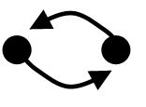
A symmetric relation is one such that if x bears it to y, then y bears it to x. (E.g. Adjacent(x,y) is symmetric, LeftOf(x,y) is not symmetric.)

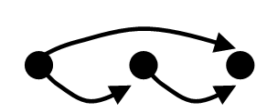
A transitive relation is one such that if x bears it to y and y bears it to z then x bears it to z. (E.g. LeftOf is transitive; DifferentShape is not transitive)

To show that a particular relation lacks one of these properties, we produce and argument and a counterexample.
E.g. Show that NotAdjacent is not transitive …
If NotAdjacent were transitive, the following argument would be logically valid:
1. NotAdjacent(a, b)
2. NotAdjacent(b, c)
3. NotAdjacent(a, c)

A counterexample to this argument:
b
c
a

Artificial relation examples
EqualToOrLeftOf(x, y) iff
x = y or LeftOf(x, y)
EqualToOrAdjacent(x, y) iff
x=y or Adjacent(x, y)
JohnOrAyesha(x, y) iff
x = John and y = Ayesha
or x = Ayesha and y = John
JohnToAyesha(x, y) iff
x = John and y = Ayesha
Quantifiers and relations
reflexive ∀x R(x,x)
symmetric ∀x∀y [ R(x,y) → R(y,x) ]
transitive
∀x∀y∀z ( [ R(x,y) ∧ R(y,z) ] → R(x,z) )
A transitive, reflexive and non-symmetric relation:
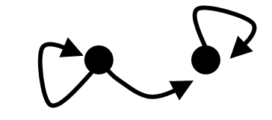
That relation is a counterexample to this argument:
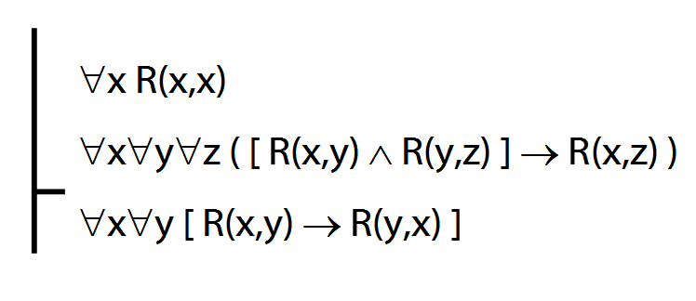
Formal statement of counterexample:
Domain: {a,b}
R : { <a,a>, <a,b>, <b,b> }

Ex. Is this argument valid?
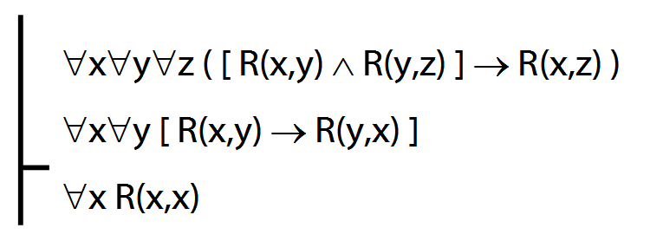

Exercises 06
For your seventh seminar
Not for fast groups
A. From the LPL textbook:
9.15–17, *9.18–19 (trans.)
10.20, 10.22
11.2 (multiple quantifiers)
12.9–10
Short of time? Skip the exercises marked *

B. Each line of the table describes a combination of properties. E.g. line 1 specifies a relation that is reflexive, symmetric and transitive, line 2 specifies a relation that is reflexive, symmetric and not transitive. Complete the table by adding an example relation on each line.

